|  |  |  |  |  |  |  |  |  |
| --- | --- | --- | --- | --- | --- | --- | --- | --- |
|  | |  |  |  | | --- | --- | --- | | CSL-220: Database Management System | | | | SEMESTER | BS CS 04 - B |  | |  | |

**Task 1:**

Create a stored function MANAGER without input parameters. It must return the total salary of all the managers in the EMP table to PL/SQL anonymous block and must be displayed in the same anonymous block.

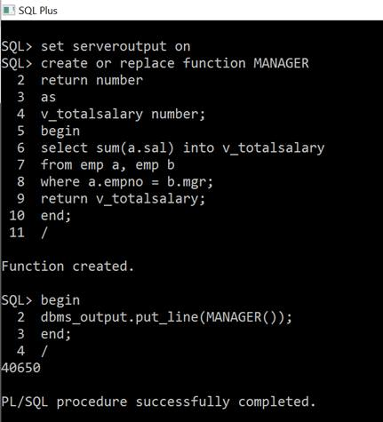

**Task 2:**

Create a stored function MANAGER2 with parameters. It must take empno as an input and must return its manager name.Write a SELECT statement to display all employees’ names and their manager names. Manager names must be displayed using MANAGER2 stored function.

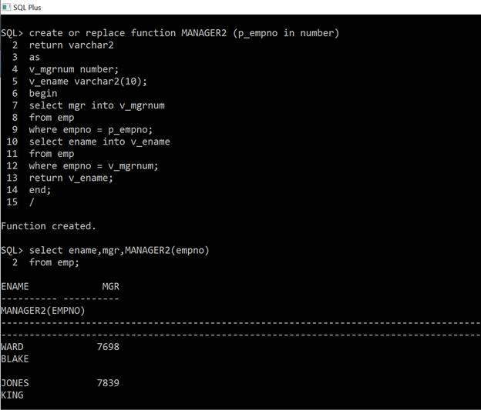

**Task 3:**

Create a stored function MANAGER3 with parameters. It must take MANAGER NAME as an input and must display all employees’ names working as CLERK under that manager. MANAGER3 must be called from a PL/SQL anonymous block.

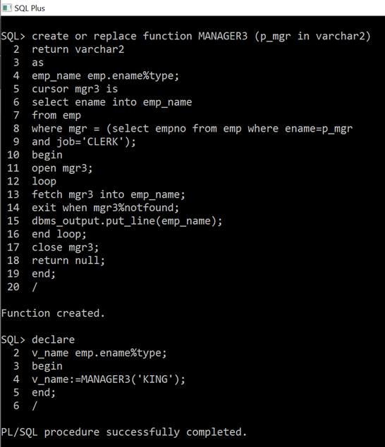

**Triggers**

**Task 1:**

Create a new table which is the replica of EMP table without records. Now write a trigger on EMP table so that whenever any DML operation is performed on EMP, original record of the EMP table must be maintained in the new table before getting changed in it.

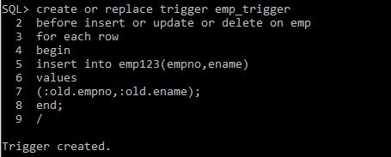

**Task 2:**Create a trigger on EMP table which stops any person from INSERT or UPDATE of the record if the new job of the affected record is CLERK and new salary is less than 5000.

